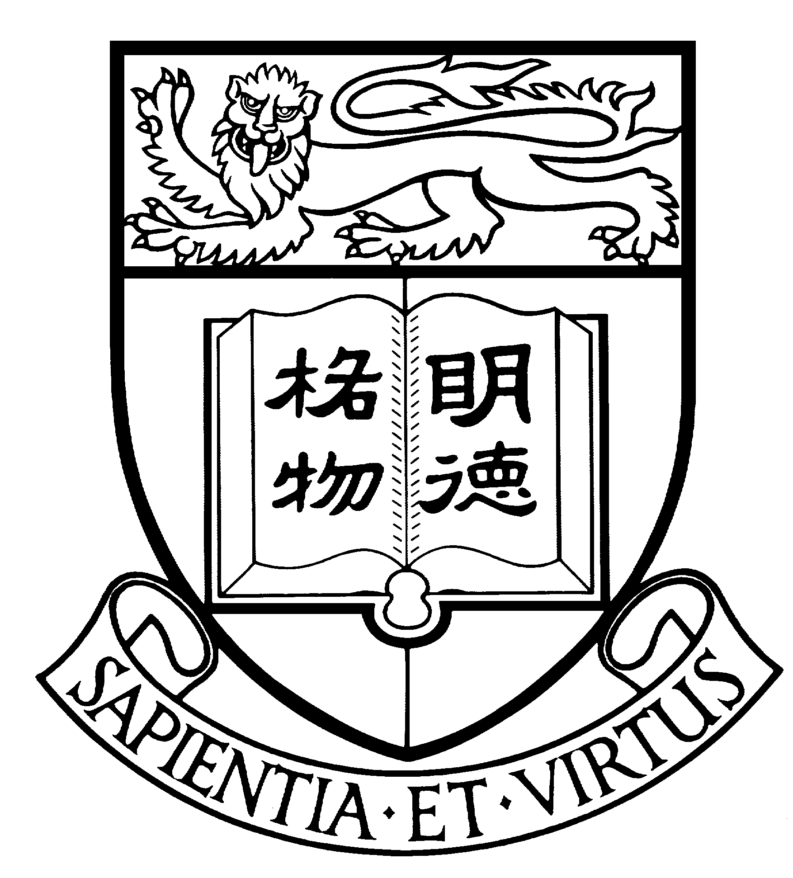
Communications and Public Affairs Office
Press Materials
The University of Hong Kong

Enquiry: 2859 2600
Website: http://www.hku.hk/cpao

Professor Vivian Yam, Philip Wong Wilson Wong Professor in Chemistry and Energy, HKU

Professor Yam is a world-renowned scientist specializing in inorganic / organometallic syntheses, supramolecular chemistry and photochemistry. Her team has designed and synthesized many new molecular functional materials that have promising optical, charge separation and light-emitting properties. Her research works in luminescent and light-absorbing materials, solar energy conversion, chemosensors and biosensors could have great impact on the development of clean renewable sources of energy, energy-efficient solid-state lighting, and environmental and sustainable developments. Her impressive research contributions to inorganic / organometallic chemistry and commitment in nurturing young scientists have gained her many awards in local and international arena. [ Note: For Professor Yam’s brief resume, please refer to the attached. ]

She was elected to Member of the Chinese Academy of Sciences in 2001 at the age of 38 as the youngest member of the Academy, and Fellow of TWAS, the Academy of Sciences for the Developing World in 2006. She was awarded the 2005 State Natural Science Award for her project on “Molecular Design and Luminescence Studies of Transition Metal Complexes with Alkynyl- and Chalcogen-Containing Ligands”, and the 2005-06 Royal Society of Chemistry Centenary Lectureship and Medal for her innovative design and synthesis of metal-based luminescent materials and novel contributions to light-induced chemical reactions. She is the first Chinese scientist to be honoured with the RSC Centenary Lectureship and Medal. She was also the recipient of the Croucher Senior Research Fellowship (2000), Japanese Photochemistry Association Lectureship Award for Asian and Oceanian Photochemist (Eikohsha Award) (2006), Hong Kong Fulbright Distinguished Scholar (2007), Croucher Foundation Senior Research Fellowship (2000-01), HKU Distinguished Research Achievement Award (2006-07), HKU Outstanding Researcher Award (1999-2000), Ten Outstanding Young Persons of Hong Kong (2002), and Hong Kong Outstanding Women Professionals and Entrepreneurs Award (2008).

She has been invited to serve as the Associate Editor of the international SCI journal, Inorganic Chemistry, published by the American Chemical Society and is the top primary journal (in terms of impact factor and total cites) in the field of Inorganic and Nuclear Chemistry. She is the first Asian inorganic chemist as well as the first inorganic chemist outside the United States to be invited to serve as Associate Editor of the journal since its first publication in 1962. She was also invited to serve as a Member of European Research Council (ERC) Advanced Grants Panel (Physical Sciences & Engineering). She currently serves as the Volume Editor of the volume on “Coordination and Organometallic Chemistry” in Comprehensive Inorganic Chemistry (Elsevier), a major review work in the field, and has served as the Volume Editor of the volume entitled “Photofunctional Transition Metal Complexes” of “Structure and Bonding” (Springer, Heidelberg) and the Guest Editor of two Special Issues of the SCI journal Coordination Chemistry Reviews (Elsevier). She also serves or has served on the International Editorial Advisory Board of most of the major SCI journals in the field of Inorganic and Organometallic Chemistry, including new RSC flagship journal, Chemical Science, and Dalton Transactions of the Royal Society of Chemistry, Inorganic Chemistry, Organometallics and ACS Nano of the American Chemical Society, Journal of Organometallic Chemistry (Elsevier), Inorganica Chimica Acta (Elsevier), and Encyclopedia of Inorganic Chemistry, Second Edition (John-Wiley & Sons), and International Editorial Board of Coordination Chemistry Reviews (Elsevier) and Comments on Inorganic Chemistry (Taylor & Francis). She also serves or has served on the Editorial Boards of the journals New Journal of Chemistry (RSC), Journal of Photochemistry and Photobiology A: Chemistry (Elsevier) and Journal of Cluster Science (Springer).
Professor YAM Wing-Wah Vivian: Brief Resume

Professor Yam Wing-Wah Vivian, Philip Wong Wilson Wong Professor in Chemistry and Energy, and Chair of Chemistry at The University of Hong Kong (HKU).

Professor Yam received a B.Sc. (First Class Hons.) in chemistry and a Ph.D. also in chemistry from HKU in 1985 and 1988 respectively. In 1997, Prof. Yam was promoted to professor and in 1999 chair professor in the Department of Chemistry at HKU.

In 2000, Professor Yam was appointed as the Head of the department for two full terms totaling 6 years. Since 2009, she became the Philip Wong Wilson Wong Professor in Chemistry and Energy.

Major Awards Received in Recent Years

2008 | Hong Kong Outstanding Women Professionals and Entrepreneurs Award
2007-08 | Frontiers in Chemical Research Distinguished Lectureship, Texas A & M University
2007 | Hong Kong Fulbright Distinguished Scholar
2006 | Fellow of the Academy of Sciences for the Developing World.
2006-07 | Distinguished Research Achievement Award, The University of Hong Kong
2006 | Japanese Photochemistry Association Lectureship Award for Asian and Oceanian Photochemists (Eikohsha Award)
2005-06 | Royal Society of Chemistry Centenary Lectureship and Medal (the first Chinese recipient)
2005 | State Natural Science Award (Second Class Prize of National Award) (a National Organization of Science and Technology Award given by the State Council of the People’s Republic of China)
2002 | Ten Outstanding Young Persons (awarded by the Hong Kong Junior Chamber)
2001 | Member of the Chinese Academy of Sciences ( the youngest scientist to be elected by then)
2000-01 | Croucher Senior Research Fellowship

Major Public Offices in Recent Years

2007-13 | Member, European Research Council (ERC) Advanced Grants Panel
2007-08 | Member of Panel of Assessors, Innovation and Technology Support Programme, Innovation and Technology Fund, Innovation and Technology Commission (ITC)
2005-07 | Member, University Grants Committee Research Assessment Exercise (RAE) 2006, Physical Sciences Panel, Research Assessment Ad Hoc Group
2003-07 | Member, Research Grants Council
1999-2004 | Member, Physical Sciences Panel, Research Grants Council

Professor Yam has supervised over 50 PhD students. She serves on numerous grant review panels in Hong Kong and overseas including the European Research Council (ERC) Advanced Grants Panel and is frequently invited to act as an external advisor or external assessor for other local and overseas universities. She also serves on numerous editorial and editorial advisory boards of international SCI journals.

