THE UNIVERSITY OF HONG KONG
FACULTY OF SCIENCE
HKU Science and Art Crossover Programme

Date: January 26, 2013 (Saturday)
Time: 8:30 am to 6:00 pm
Venue: CPD-3.28, 3/F, Central Podium Level, Centennial Campus, Main Campus, The University of Hong Kong
Target: F.1 to F.3 students of local secondary schools and Year 7 to Year 9 students of international schools

Time | Event
08:30 | Registration
09:15 | Opening Ceremony
9:25 | Lecture 1: “Geometry and Origami” by Dr Patrick Tuen Wai Ng, Department of Mathematics, Faculty of Science
10:05 | Lecture 2: “Lotus Effect” by Dr Tony Shien Ping Feng, Department of Mechanical Engineering, Faculty of Engineering
10:45 | Tea Break
11:00 | Lecture 3: “Science of Painting” by Dr Aleksandra B. Djurišić, Department of Physics, Faculty of Science
11:40 | Briefing on the Afternoon Workshops
12:00 | Lunch
13:00 | Parallel Science/Art Workshops
17:15 | Closing Ceremony

Workshop details
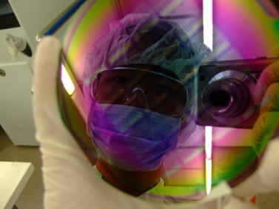
Each student will attend one of the following workshops:
Workshop 1. Capture the Moment in a Laboratory
Location: Eliot Hall Room 201
In this workshop, students will learn basic photography techniques such as composition and lighting from experts from Journalism Media Studies Centre. Laboratory tour will be arranged for the students to apply their just learned techniques to capture the special moment in laboratories.

Workshop 2. Unwrapping Science in Art
Workshop 2A. Platonic and Archimedean solids + String Arts
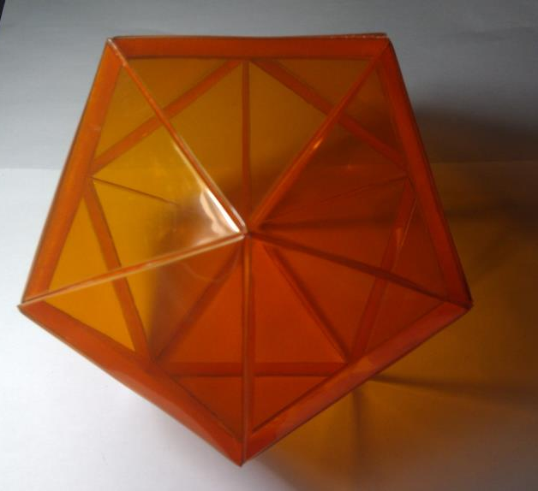
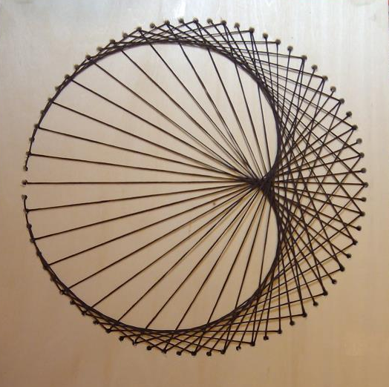
Location: CPD-LG61 (Centennial Campus)
Welcome to the world of Euclidean geometry! In the first part of this workshop, students will learn to make Platonic solids and Archimedean solids using colourful Perspex. Later on, students will learn String Arts and will organize coloured thread strung between points to form fascinating geometric patterns.

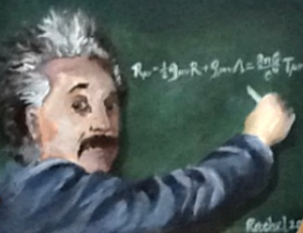
Workshop 2B. Painting on Canvas
Location: Library Extension 4 and 5
After the lectures in the morning workshop, students should have some basic ideas on the nature of science. In this workshop, students are expected to manifest the abstraction of science in the form of painting. They may depict scientists or express their views on scientific developments.
Acknowledgement: This workshop is sponsored by:
Applique (http://www.applique.com.hk/home.php),
Free Art Work Shop (http://www.facebook.com/FreeArtWorkShop),
Royal Talents (http://www.talens.com/en-gb),
168 Gallery (http://www.168galleryhk.com) and
Swiss Art Studio (http://www.swissartstudio.com).

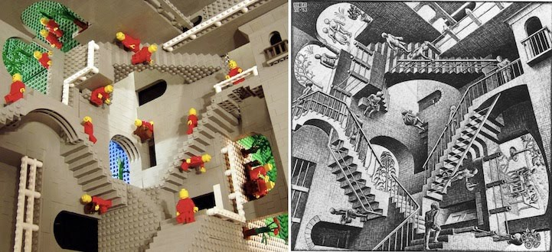
Workshop 3. Create the Impossibility by LEGO® - Learn Escher, Go On!
Location: CPD-LG62 (Centennial Campus)
In this workshop, students will learn how to make the impossible constructions illustrated by the Dutch painter MC Escher. Some of his works such as Belvedere and Relativity will be built by LEGO®, and our LEGO® experts from will assist our students to realize the impossibility.

Acknowledgement: This workshop is sponsored by AA Place (http://www.aaplace.hk/).

Other sponsors: Kleenex (http://www.kcprofessional.com.hk/brands/kleenex)
Coastal Scents HK (http://www.coastalscentshk.com)

