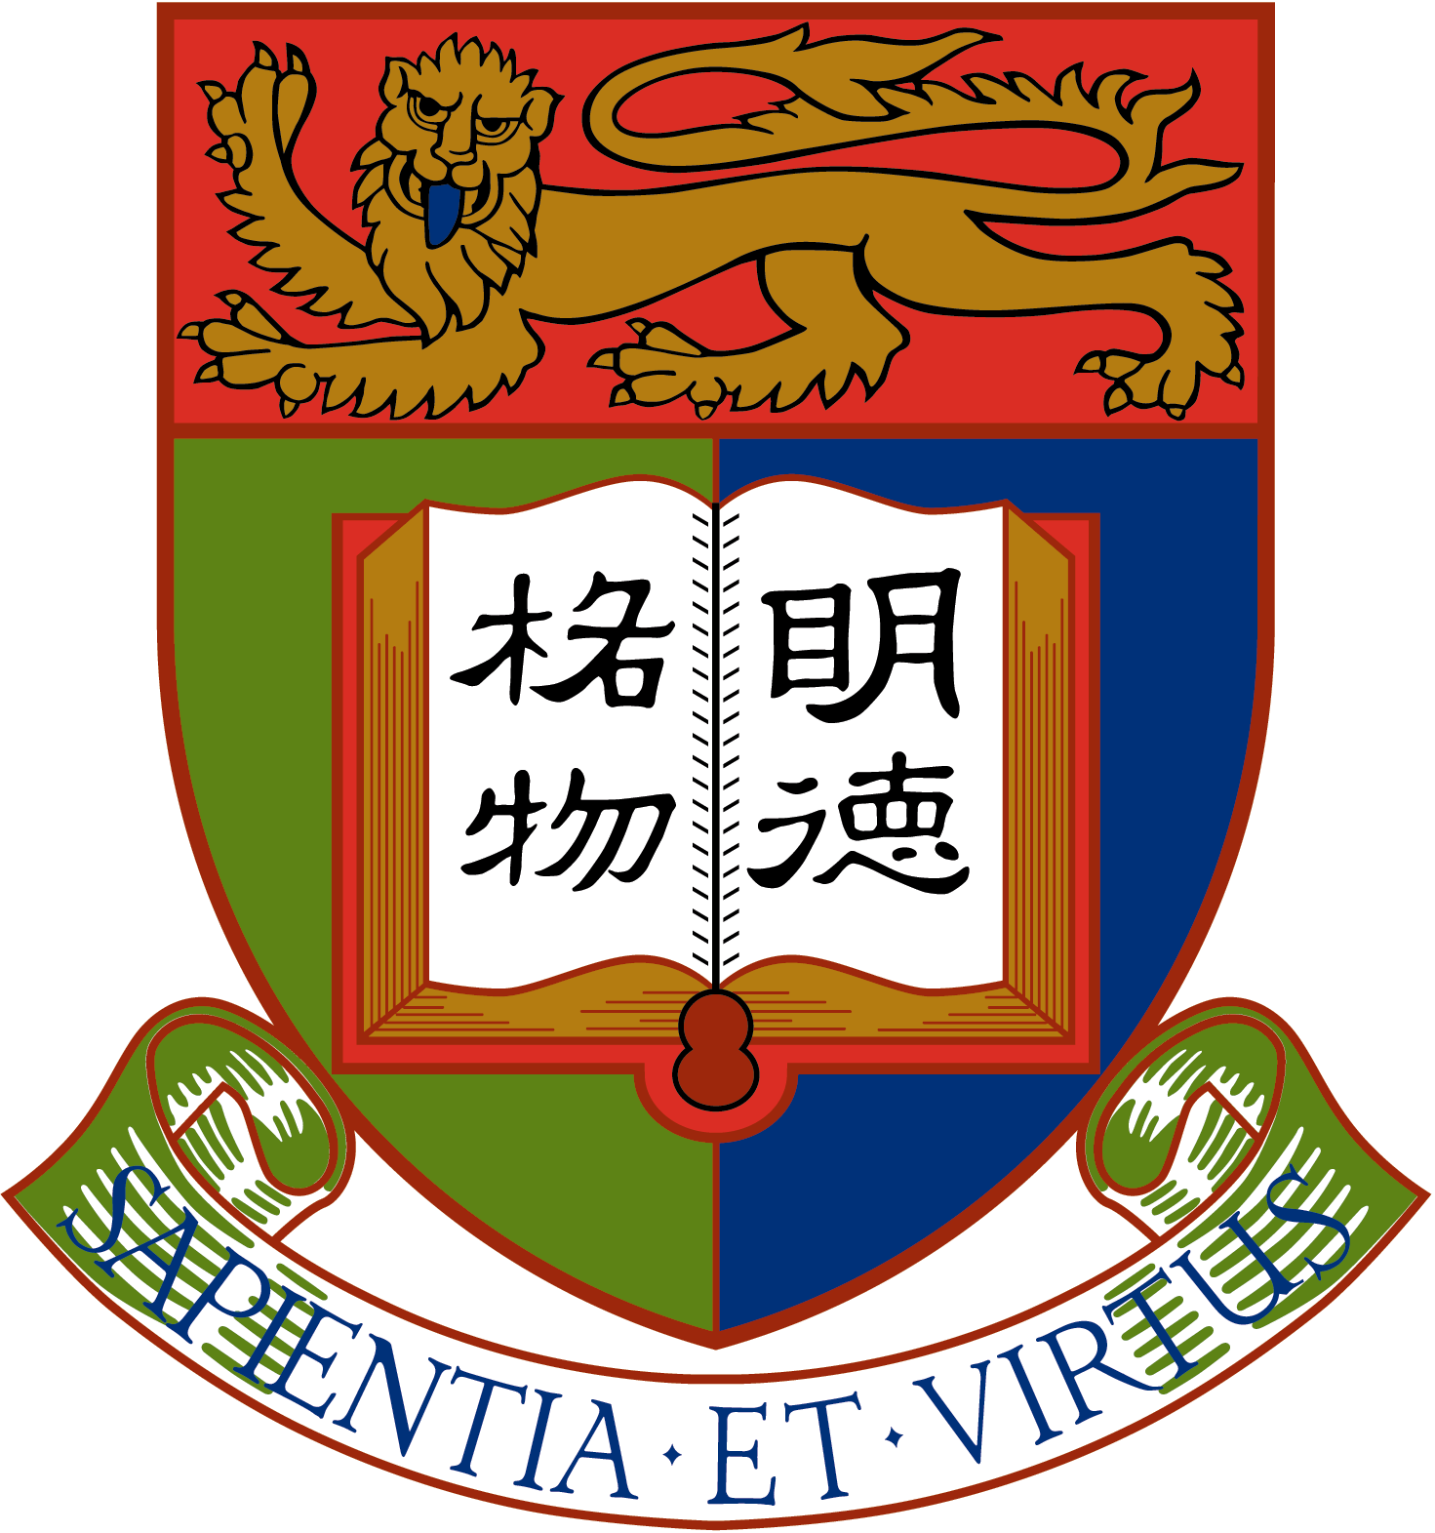

Brief Report: A Study of Hong Kong
Adolescents’ Social Identification

Department of Psychology
The University of Hong Kong

June 12, 2007

Brief Report: A Study of Hong Kong Adolescents’ Social Identification

Preamble
Hong Kong people’s attitudes toward Hong Kong, China, Hong Kong people, and Mainlanders are closely related to their social identity. In 1995, a group of psychologists began a study investigating Hong Kong adolescents’ social identification before and after the return of sovereignty of Hong Kong to China in 1997. In this two-wave study, which spans over 12 years, we surveyed over 13,000 Hong Kong adolescents’ social identification and their attitudes toward China, Hong Kong, Hong Kong people and Mainlanders.

The first wave of survey was conducted in late 1996 with 9,226 students in 21 secondary schools. The second wave of survey was carried out in late 2006 with 3,993 students in 12 secondary schools. Table 1 shows the demographics of the respondents.

Table 1. Demographics of respondents

 | 1996 | 2006
Sample | 9,226 | 3,993
Gender | Male: 44% | Male: 50%
 | Female: 56% | Female: 50%
Average age | 15.40 | 15.52
Grade | Form 3: 33.6% | Form 3: 33.3%
 | Form 4: 33.7% | Form 4: 33.1%
 | Form 5: 32.7% | Form 5: 33.6%
Birthplace | Hong Kong: 87.2% | Hong Kong: 78.8%
 | Mainland China: 10.9% | Mainland China: 18.1%
 | Others:1.8% | Others: 3.1%
Number of participating schools | 21 | 12

The main findings of these two surveys indicate that:
- Ten years after the return of sovereignty, there are more Hong Kong adolescents claiming dual identities (Chinese, secondarily Hongkonger), and fewer claiming sole identities (Hongkonger, Chinese).
- The more respondents identified themselves as Chinese, the more positive their attitudes are towards China and Mainlanders. This relationship has remained stable over the 10-year period.
- In these 10 years, Hong Kong adolescents’ political and economic evaluation of China has become more positive, and their confidence in themselves and the future of Hong Kong has also improved. However, their views of Mainlanders remain quite negative.
- Although Hong Kong adolescents’ views of the nation and the country have not changed much 10 years after the return of sovereignty, they have begun to associate responsibilities for the nation with support for the state’s policies.
- Ten years after the return of sovereignty, there are more Hong Kong adolescents claiming dual identities (Chinese, secondarily Hongkonger), and fewer claiming sole identities (Hongkonger, Chinese).

In the two waves of survey, we asked respondents to choose from 4 social identities the one that can best describe them. These 4 identities are:
- Hongkonger
- Hongkonger, secondarily Chinese
- Chinese, secondarily Hongkonger
- Chinese
Table 2 and Figure 1 display the distribution of the choice of social identity in 1996 and 2006.

Table 2. Adolescents’ Social Identification in 1996 and 2006

 | 1996 | 2006
Hongkonger | 33.9% | 28.7%
Hongkonger, secondarily Chinese | 40.0% | 39.4%
Chinese, secondarily Hongkonger | 15.8% | 22.3%
Chinese | 10.4% | 9.6%

Hongkonger Hongkonger, Chinese, Chinese
Secondarily Secondary
Chinese Hongkonger

Figure 1. Adolescents’ social identification in 1996 and 2006.
- In 1996, most students claimed to be “Hongkonger, secondarily Chinese” and few claimed to be “Chinese.” This pattern was maintained in 2006 but with an obvious change: more adolescents identified themselves as “Chinese, secondarily Hongkonger” and fewer adolescents identified themselves as “Hongkonger.”
- This increase in claiming the dual social identity of “Chinese, secondarily Hongkonger” can be observed among both adolescents born locally and their Mainland-born counterparts.
- Figure 2 shows that in 2006, for those who were born in Hong Kong, relative to 1996, more of them claimed to be “Chinese, secondarily Hongkonger” and fewer of them claimed to be “Hongkonger.” For respondents who were born in the Mainland, relative to 1996, more of them claimed to be “Chinese, secondarily Hongkonger” in 2006 and fewer of them claimed to be “Chinese.”

Figure 2. Social identity and place of birth.

- The more respondents identified themselves as Chinese, the more positive their attitudes are towards China and Mainlanders. This relationship has remained stable over the 10 year period.

- In our 1996 survey, we found that the more respondents identified themselves as “Chinese,” the more positive their attitudes were towards China and Mainlanders.
- We transformed the four social identities into a scale: “Hongkonger” is “1,” “Hongkonger, secondarily Chinese” is “2,” “Chinese, secondarily Hongkonger” is “3,” and “Chinese” is “4.” The higher the score, the more one identifies with the identity of “Chinese.” Conversely, the lower the score, the more one identifies with the identity of “Hongkonger.” We correlated this scale with the adolescents’ attitudes. The correlation coefficients are presented in Table 3. Correlation coefficients range from 1- to +1 with 0 indicating lack of association, negative number indicating negative association, and positive number indicating positive association.
- Table 3 shows that the more adolescents identified with the identity of “Chinese,” the more
    - they trusted Mainlanders,
    - hoped the differences between Mainlanders and Hong Kong people would diminish,
    - were proud of being Chinese,
    - felt responsible for the future of China, felt that Chinese culture was superior to Western culture,
    - were ready to accept people and things from the Mainland, and were willing to build good relationships with Mainlanders; and
the less they
    - felt that Hong Kong people were superior to Mainlanders,
    - China should be completely westernized for modernization, and
    - would avoid people and things from the Mainland.
- These relations are also observed in 2006 and have remained stable over the 10-year period.

Table 3. Correlation between Social Identification and Attitudes

 | 1996 | 2006
Trust in Mainlanders | .32 | .33
Hope the differences between Mainlanders and Hong Kong people would diminish | -.25 | -.30
Hong Kong people are superior to Mainlanders | -.33 | -.32
Proud of being Chinese | .38 | .40
Responsible for the future of China | .40 | .41
Chinese culture is better than Western culture | .22 | .22
China should be completely westernized for modernization | -.20 | -.22
Accept people and things from the Mainland | .36 | .35
Avoid people and things from the Mainland | -.28 | -.30
Willing to build good relationships with Mainlanders | .31 | .34

- In these 10 years, Hong Kong adolescents’ political and economic evaluation of China has become more positive, and their confidence in themselves and the future of Hong Kong has also improved. However, their views of Mainlanders remain quite negative.

- In the last 10 years, Hong Kong adolescents have adjusted their political and economical evaluations of China and Hong Kong. In 1996, Hong Kong adolescents thought that relative to China, Hong Kong had fairly good political and economical capabilities. This view has been appreciably adjusted in the last 10 years.
- Perhaps because of improved evaluation of China’s political and economical capabilities, Hong Kong adolescents have significantly moderated their willingness to publicly criticize political, economic, cultural, and social issues in China.
- However, Hong Kong adolescents have not lowered their confidence in Hong Kong or themselves. Relative to the adolescents in 1996, the adolescents in 2006 were significantly more confident in the future of Hong Kong and themselves; they were also more proud of being Chinese.
- At the same time, evaluations of Hong Kong people and Mainlanders have remained stable in the 10-year period. In our 2006 survey, Hong Kong adolescents held more positive attitudes towards Hong Kong people than for Mainlanders: they trusted Hong Kong people more than Mainlanders, and tended to think that Hong Kong people were superior to Mainlanders and that Chinese did not compare well with Westerners. This pattern of results is similar to that of 10 years ago.
- If there is any change, Hong Kong adolescents’ evaluation of Mainlanders has become worse: relative to adolescents in 1996, adolescents in 2006 thought that compare to Westerners, Chinese emerged worse than before, and they were even less willing to build good relationships with Mainlanders

Table 4. Changes in Hong Kong Adolescents’ Attitudes in the Last 10 Years

 | Average in 1996 | Average in 2006
Hong Kong has more political power than China.* | 4.3 | 3.7
Hong Kong has more economic power than China.* | 5.7 | 4.4
Publicly criticize political, economic, cultural, and social issues in China* | 3.3 | 2.7
Confidence in Hong Kong in the next 10 years.* | 4.2 | 5.0
Self efficacy in the next 10 years.* | 4.1 | 4.8
Proud of being Chinese.* | 3.9 | 4.4
Proud of being Hong Kong people. | 5.1 | 5.1
Trust in Hong Kong people | 4.8 | 4.9
Trust in Mainlanders | 3.0 | 3.2
Hong Kong people are superior to Mainlanders | 5.4 | 5.2
Build good relationships with Mainlanders* | 3.9 | 3.3
Chinese are superior to Westerners* | 3.6 | 3.2
Note: All questions were answered on a 7-point scale. “1” represented the lowest extent, “7” represented the highest extent, and “4” represented a neutral stance. * indicated that there is a significant difference between the values from the two surveys on a particular item.

- Although Hong Kong adolescents’ views of the nation and the country have not changed much 10 years after the return of sovereignty, they have begun to associate responsibilities for the nation with support for the state’s policies.

- Adolescents’ social identification is related to their views of the nation. We used 3 items to access respondents’ views:
    - their sense of responsibility for the future of the nation and its people,
    - their evaluation of Chinese culture, and
    - their agreement to the statement “To be patriotic, one will have to support the state’s policies.”

Table 5. Nationalistic Views of Adolescents with Different Social Identity

 | Hongkonger | Hongkonger/  Chinese | Chinese/  Hongkonger | Chinese | Overall
 | 1996
Sense of responsibility for the future of one’s nation and its people | 3.7 | 4.4 | 5.0 | 5.1 | 4.3
Positive evaluation of Chinese culture | 3.8 | 4.2 | 4.6 | 4.7 | 4.2
To be patriotic, one will have to support the state’s policies. | 3.0 | 3.18 | 3.2 | 3.3 | 3.1
 | 2006
Sense of responsibility for the future of one’s nation and its people | 3.6 | 4.3 | 4.9 | 5.0 | 4.3
Positive evaluation of Chinese culture | 4.0 | 4.4 | 4. 8 | 4.9 | 4.4
To be patriotic, one will have to support the state’s policies. | 3.1 | 3.2 | 3.4 | 3.3 | 3.2
Note: All questions were answered on a 7-point scale. “1” represented the lowest extent, “7” represented the highest extent, and “4” represented a neutral stance.

- Several points are noteworthy in Table 5.
    - More the adolescents identified with Chinese, more would they feel responsible for the future of the nation and its people and more positive would they evaluate the Chinese culture.
    - However, there was no relation between social identification and agreeing that to be patriotic, one will have to support the state’s policies. Regardless of whether respondents identified themselves as “Hongkonger” or “Chinese,” Hong Kong adolescents tend to disagree that to be patriotic, one will have to support the state’s policies. All average responses are below the neutral stance (4) on the scale. Hong Kong adolescents seem to be able to distinguish being loyal to one’s nation from being loyal to a government’s policies. Secondly, Hong Kong’s adolescents’ responses on the three items have not changed much over the past 10 years.
    - The ratings in 2006 are comparable to those in 1996. There is no meaningful difference between the two sets of ratings.

- Although Hong Kong adolescents’ responses on these 3 items have remained stable in the last 10 years, a notable change has emerged in the relation between two of the items.
    - In 1996, there was no relation between feeling responsible for the future of the nation and its people and believing that one had to support the state’s policies to be patriotic (correlation = .08), indicating that even if adolescents felt responsible for the future of the nation and its people, they did not necessarily agree that they have to support the country’s policies to be patriotic.
    - However, in 2006, there is a definite relation between the two items (correlation = .17), indicating that the more Hong Kong adolescents felt responsible for the future of the nation and its people, the more they agreed that they had to support the state’s policies to be patriotic.

- Ten years ago, our research team conducted similar large scale surveys in five major Mainland cities (Xian, Beijing, Guangzhou, Shenzhen, and Shanghai). Regardless of the respondents’ social identity, we found that Mainland adolescents
    - tended to agree that one had to support the state’s policies to be patriotic (average rating = 4.86), and
    - the more they feel responsible for the future of the nation and its people, the more they agreed that one had to support the state’s policies to be patriotic (correlation = .27).

- Today, we found that among Hong Kong adolescents, there is a similar tendency for a sense of responsibility for the future of the nation and its people to be accompanied by agreeing that one has to support the country’s policies to be patriotic. This finding deserves prudent consideration from educators who are concerned with civic education.

Conclusion

- Ten years after the return of sovereignty, more Hong Kong adolescents claimed dual identities (Chinese, secondarily Hongkonger), fewer Hong Kong adolescents claimed sole identities (Hongkonger, Chinese).
- The more respondents identified themselves as Chinese, the more positive their attitudes are towards China and Mainlanders. This relationship has been very stable over the 10-year period.
- In these 10 years, Hong Kong adolescents’ political and economic evaluation of China has become more positive, and their confidence in themselves and the future of Hong Kong has also improved. However, their views of Mainlanders have remained quite negative.
- Although Hong Kong adolescents’ views of the nation and the country have not changed much 10 years after the return of sovereignty, they have begun to associate responsibilities for the nation with support for the state’s policies.

The results of the two surveys urge us to rethink the following questions:
- How successful is the civic education in Hong Kong after the turnover?
- What are the possible meanings of Chinese identity? If we want Hong Kong adolescents to construct a Chinese identity, what do we encourage them to explore and identify with?
- Is there only one way to be patriotic? If we want Hong Kong young people to be patriotic, what are the different ways of being patriotic we can encourage them to explore?
These are the questions we should bear in mind when we design and implement civic education.

Members of research team:
Shui-fong Lam | Associate Professor, Department of Psychology, The University of Hong Kong
Ivy Lau | Practical Assistant Professor, School of Social Sciences, Singapore Management University
Chi-yue Chiu | Professor, Department of Psychology, University of Illinois, Urbana-Champaign
Ying-yi Hong | Professor, Department of Psychology, University of Illinois, Urbana-Champaign
Acknowledgement: This research is supported by a generous donation from Ms. Serena Yang Hsieh Chi and two research grants from the University of Hong Kong.

