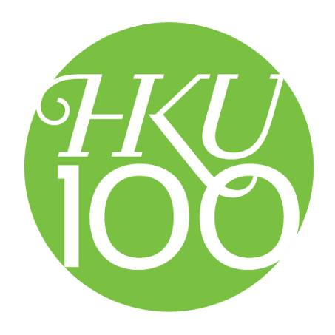
The “HKU 100” symbol

The “HKU 100” symbol is the main visual element of the HKU Centenary Signature.

The circular shape, symbolising fulfilment and perfection, features two distinctly different typefaces: an historical swash italic for the letters ‘HKU’, echoing the classical architecture of the Main Building, and a very contemporary sans serif for the numerals ‘100’. The typefaces strive to reach out beyond the circular confine, ever wanting to achieve more.

Dark green is the traditional University colour. A more vibrant and dynamic shade of green is selected as the primary colour for the Centenary Signature.

The University of Hong Kong boasts of a proud heritage and embraces the challenging future. The counter-play of tradition and modernity reflects the excitement of this very historic moment.

Designer: Mr Tommy Li
“This is an exciting project and I am honoured to have been involved. The Centenary of HKU represents the centenary of tertiary education in Hong Kong. HKU has grown with Hong Kong. HKU is also a brand that Hong Kong people have grown up with, and we are proud of it. I believe the signature, which I see as more than just a logo, reaffirms the uniqueness of HKU.”

Tommy Li is one of Hong Kong's most distinguished designers.

2010.12.15

「港大100」標誌

圓形圖案象徵圓滿。內藏兩款風格迥異的字體︰斜體英文字母「HKU」的Swash字款，呼應大學本部大樓建築的古典線條；數目字「100」的Sans Serif字款展示現代氣息。而「HKU 100 」亦不甘停留在圓框之內，不斷求突破。

深綠，一向為港大傳統顏色。港大百周年校慶，則在基調上變奏，採用了生意盎然的青綠。

設計:李永銓
「能夠參與這設計工作，我深感榮幸。港大與香港一起成長，是香港人熟悉的品牌。港大的百周年校慶，正代表著香港高等教育的騰飛，為廿一世紀作貢獻。『港大100』的標誌簡潔中見典雅，融合傳統與現代，展現港大的新姿態，迎向未來。」

李永銓為香港著名設計師

2010.12.15

