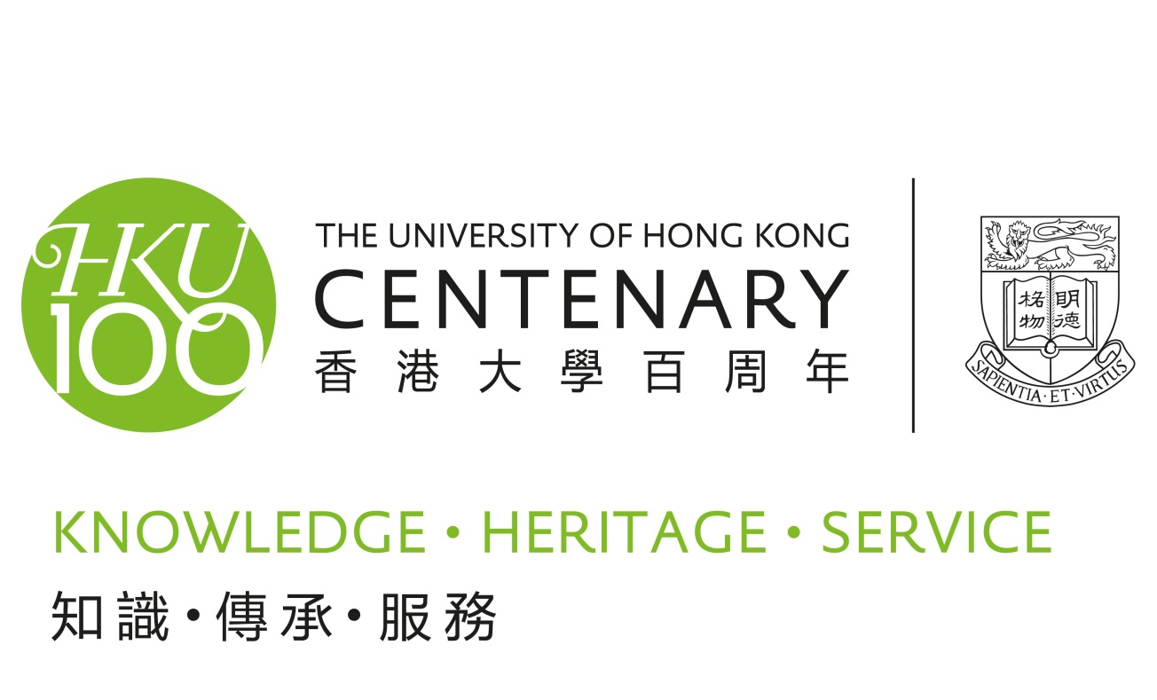
http://100.hku.hk
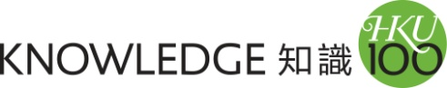
True to the Latin motto “Sapientia et Virtus”, Wisdom and Virtue, the University as an intellectual hub and leading institution of higher learning will share with the community the joy of creating knowledge and knowledge exchange.
The Centenary Distinguished Lectures (2010 - 2012)
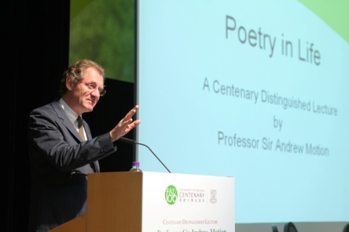
Delivered by Nobel Laureates and distinguished scholars from a wide range of disciplines, the Lectures bring some of the most brilliant minds of today to HKU, to share their expertise, experience and world-class scholarship with the University community and the public.

Lunch with a Laureate (2010 - 2012)
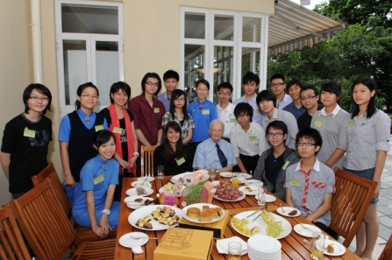
‘Lunch with a Laureate’ is an extension of the Centenary Distinguished Lectures. It provides a rare opportunity for senior secondary school students and university undergraduates to meet with world-renowned Nobel Laureates and distinguished scholars over an informal lunch. The students will not only have the chance to learn from them, but also to initiate discussion, exchange views, and experience what Knowledge Exchange is truly about.

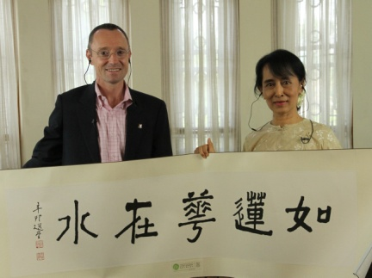
Figures

- No. of lecture: 10 (The last lecture will be held in Feb 2012)
- Lectures covered 5 different disciplines (Economics, Medicine, Arts, Science and Social Sciences)
- Over 3,400 HKU members and public attended the lectures
- 131 students from 39 secondary schools attended the Lunch with a Laureate activities
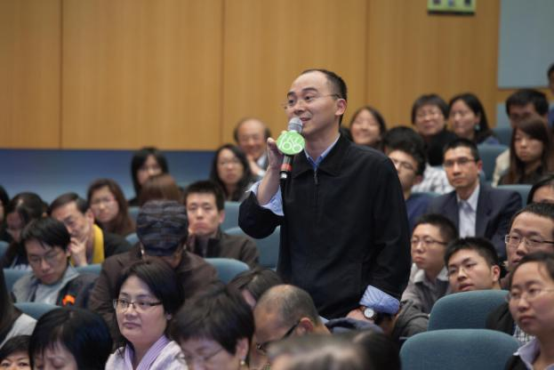
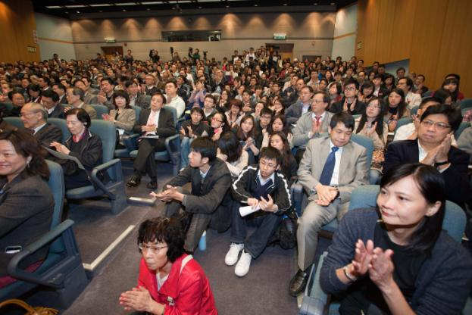
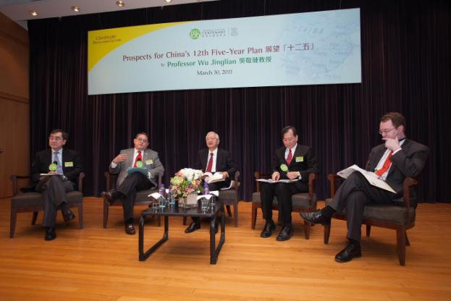
http://100.hku.hk

Centenary Distinguished Lectures 2010 - 2012

 | Date | Speakers | Topics
1 | September 20, 2010 | Professor Gary Becker  Recipient of Nobel Memorial Prize in Economic Sciences, 1992 | Causes of Worldwide Boom in Higher Education, Especially of Women
2 | November 22, 2010 | Professor Françoise Barré-Sinoussi  Recipient of Nobel Prize in Physiology or Medicine, 2008 | HIV/AIDs – a Scientific and Human Adventure in Response to an Emerging Epidemic
3 | March 10, 2011 | Professor Sir Andrew Motion  Poet Laureate of the United Kingdom, 1999 – 2009 | Poetry in Life
4 | March 18, 2011 | Professor Kurt Wüthrich  Recipient of Nobel Prize in Chemistry, 2002 | The Protein Universe and Daily Life
5 | March 30, 2011 | Professor Wu Jinglian  Renowned Economist in China | Prospects for China’s 12th Five-Year Plan
6 | May 3, 2011 | Professor Elinor Ostrom  Recipient of Nobel Prize in Economic Sciences, 2009 | Rethinking Environmental Protection and Politics
7 | May 24, 2011 | Professor Peter Doherty  Recipient of Nobel Prize in Physiology or Medicine, 1996 | Virus Killer and Killer T Cells
8 | May 30, 2011 | Aung San Suu Kyi  Recipient of Nobel Peace Prize in 1991 | A Centenary Dialogue with Aung San Suu Kyi
9 | Dec 2, 2011 | Professor Elizabeth Blackburn  Recipient of Nobel Prize in Physiology or Medicine, 2009  Professor Susan Desmond-Hellmann  Chancellor of the University of California, San Francisco | The Future of Medicine: Connecting Patients to Promising Research
10 | Feb 22, 2012 | Sir Martin Evans  Recipient of Nobel Prize in Physiology or Medicine, 2007 | Lecture will be held in Feb 2012

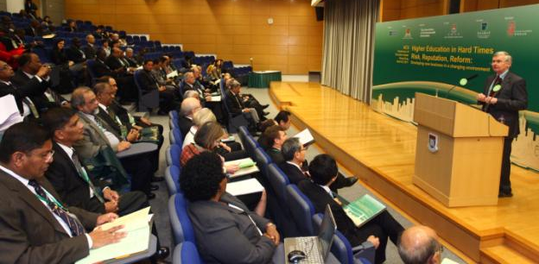
ACU Conference of Executive Heads (April 6 – 8, 2011)
"Higher Education in Hard Times - Risk, Reputation, Reform: Developing new business in a changing environment"

177 vice-chancellors and representatives from over 100 universities and institutions, representing 21 countries and 6 continents attended the Conference organised by the Association of Commonwealth Universities (ACU), and co-hosted by the three local ACU member universities including HKU, The Chinese University of Hong Kong and The Open University of Hong Kong.
http://www.acu.ac.uk/conferences/executive_heads_hong_kong_2011/Index

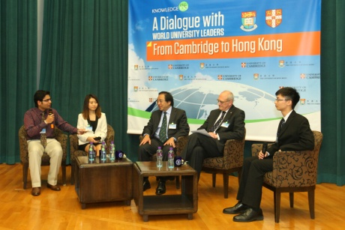
A Dialogue with World University Leaders- From Cambridge to Hong Kong (April 12, 2011)
The Dialogue with World University Leaders event brought together Professor Sir Leszek Borysiewicz, Vice-Chancellor of the University of Cambridge, and Professor Lap-Chee Tsui, HKU Vice-Chancellor to discuss the opportunities and challenges facing universities in the UK, in Hong Kong and around the world. The dialogue was guided and directed by three HKU student panellists.
http://www.cpao.hku.hk/dialogue/

A Night at the Science Museum (Nov 2011)
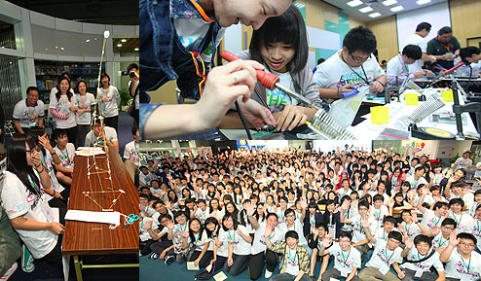
600 students and teachers from 60 secondary schools joined “A Night at the Science Museum” co-organised by The Faculty of Science and The Faculty of Engineering of The University of Hong Kong in conjunction with the Hong Kong Science Museum, and the IBM. For the first time ever, the Science Museum opened its doors at night, for students to attend workshops and lectures organised by HKU professors and students.

The event is to celebrate the 100th Anniversary of the University of Hong Kong, 20th Anniversary of the Hong Kong Science Museum and 100th Anniversary of IBM.
http://www.scifac.hku.hk/projects/nightatmuseum
http://jmsc.hku.hk/sites/science-museum/

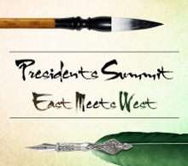
Presidents Summit
“East Meets West: Synergy, Competition or Collaboration”
(Dec 17 – 18, 2011)
The Presidents Summit is an opportunity for leaders from international universities to discuss and debate the theme of “East Meets West” in the context of higher education globally, and will include issues such as synergy, competition and collaboration, internationalization, mass vs. elite education, public vs. private funding and current challenges in higher education from different international perspectives. 130 university presidents and representatives from 68 universities will participate at the Presidents Summit.
http://www.als.hku.hk/hkucao/ps2011/
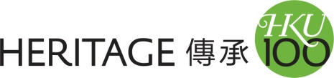
As we reflect upon our legacy, we project our vision for second century.

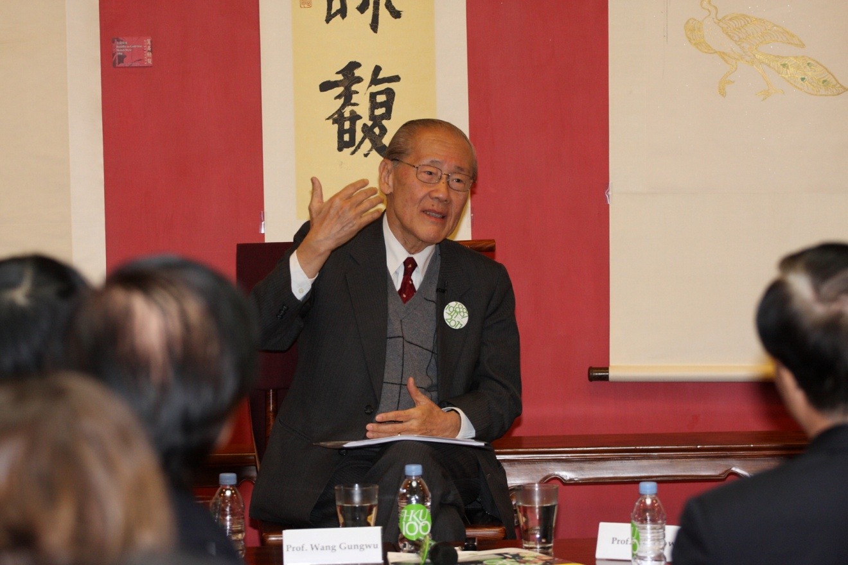
“1887, 1911, 2011… Decoding HKU”
A Conversation with Professor Wang Gungwu (Jan 11, 2011)
In the Conversation, Professor Wang Gungwu, former Vice-Chancellor and world-renowned historian, reflected on the significant events in 1887 and 1911 that led to the founding of the University. He shared his insights on how history could inform the 2011 celebrations and HKU's role in a globalised and fast-changing world. He also explored HKU's future development in the context of China's rise to become the second largest economy in the world.
http://100.hku.hk/decodinghku/index1.html

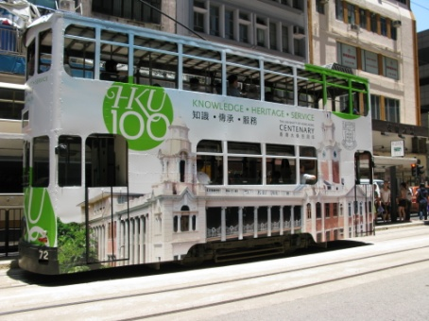
HKU 100 Tram
Hong Kong Tram Trail: Traces of Urban Development
(Aug – Dec 2011)

The "HKU 100" Tram, bearing the image of the iconic 100-year-old Main Building of the University, was launched on August 6, 2011 and will serve the public until the end of 2011.

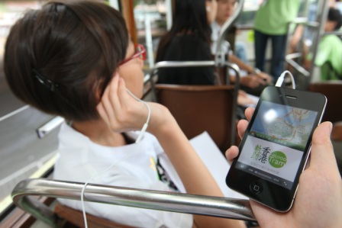
The University of Hong Kong also launched a free mobile app "Hong Kong Tram Trail - Traces of Hong Kong’s Urban Development". By making use of this app, tram passengers can have self-guided tours and learn about the changes of urban Hong Kong.

With the aim to introduce the urban history and development to the general public, the mobile app covers the urban history and development of Hong Kong along the tram way from Western District to Causeway Bay.
http://www.dupad.hku.hk/cusup/tram/
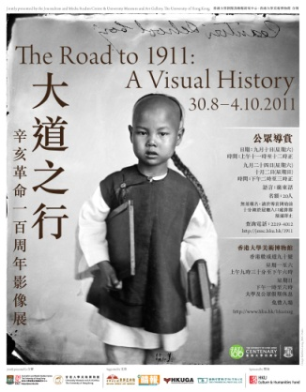

The Road to 1911: A Visual History (Aug – Oct 2011)
The "1911" exhibition features an extraordinary selection of 86 photographs brought together for the first time from collections worldwide by Liu Heung Shing, a Pulitzer Prize-winning photo-journalist. The photographs, which date from the 1860s to the early 1920s, provide an insight into the origins of modern China, in which Hong Kong played a key role. They illustrate the social conditions and attitudes of the era, the atmosphere inside the imperial court in the dying days of the Qing Dynasty, the lives of the mighty and the poor, and various events that helped shape the transition of China from the empire to the republican era.
http://jmsc.hku.hk/sites/1911/

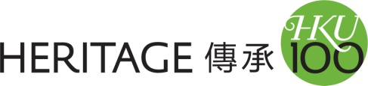
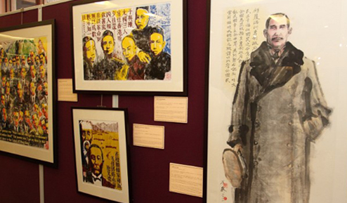
The Centenary of China’s 1911 Revolution:
Paints and Woodcuts by Fong So (Sep – Oct 2011)
Mr Fong So's series of paintings and woodcut prints on the centenary of the Xinhai Revolution is an artist's interpretation and reflection of the lifetime of Dr Sun Yat-sen and his legacy. It is an attempt by the artist to explore, through a series of artworks, what China has been through over the past century and what the future holds for Chinese people. Special emphasis is given to the unique role played by Hong Kong during this period.
http://100.hku.hk/fongsoexhibition/

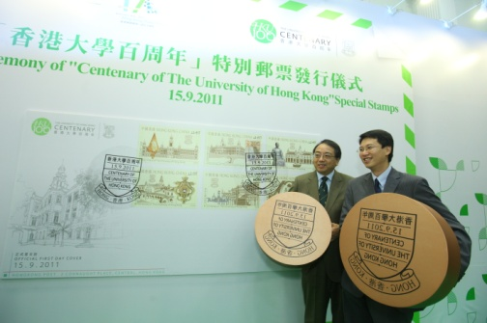
“Centenary of the University of Hong Kong” Special Stamps
(Sep 15, 2011)
Hongkong Post issued a set of commemorative stamps with the theme "Centenary of The University of Hong Kong" to mark the 100th anniversary of the University of Hong Kong. The commemorative stamps show images of the Main Building - a revered heritage building located on the university campus - as well as some historical items, each of which has a special place in the journey over time of this celebrated academic institution.
Stamps sample：http://100.hku.hk/download/hku_booklet_final.pdf

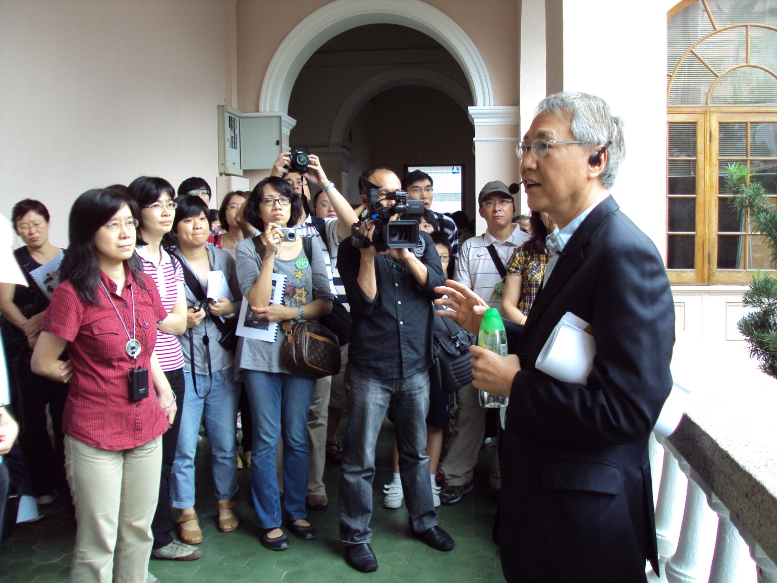
HKU Heritage Trails (Nov 2011 – Mar 2012)
The HKU Heritage Trails is a series of special campus tours. The first tour was held in Nov 2011 and the tours will be held monthly until Mar 2012. Each month will embrace a different theme. Led by "Scholastic Tour Leaders", the purpose of the tours is to give the community at large, especially the younger generations, the opportunity to gain a greater understanding of the history and architecture of HKU, as well as Hong Kong culture, and pass that knowledge on to future generations.
http://100.hku.hk/heritage/trails

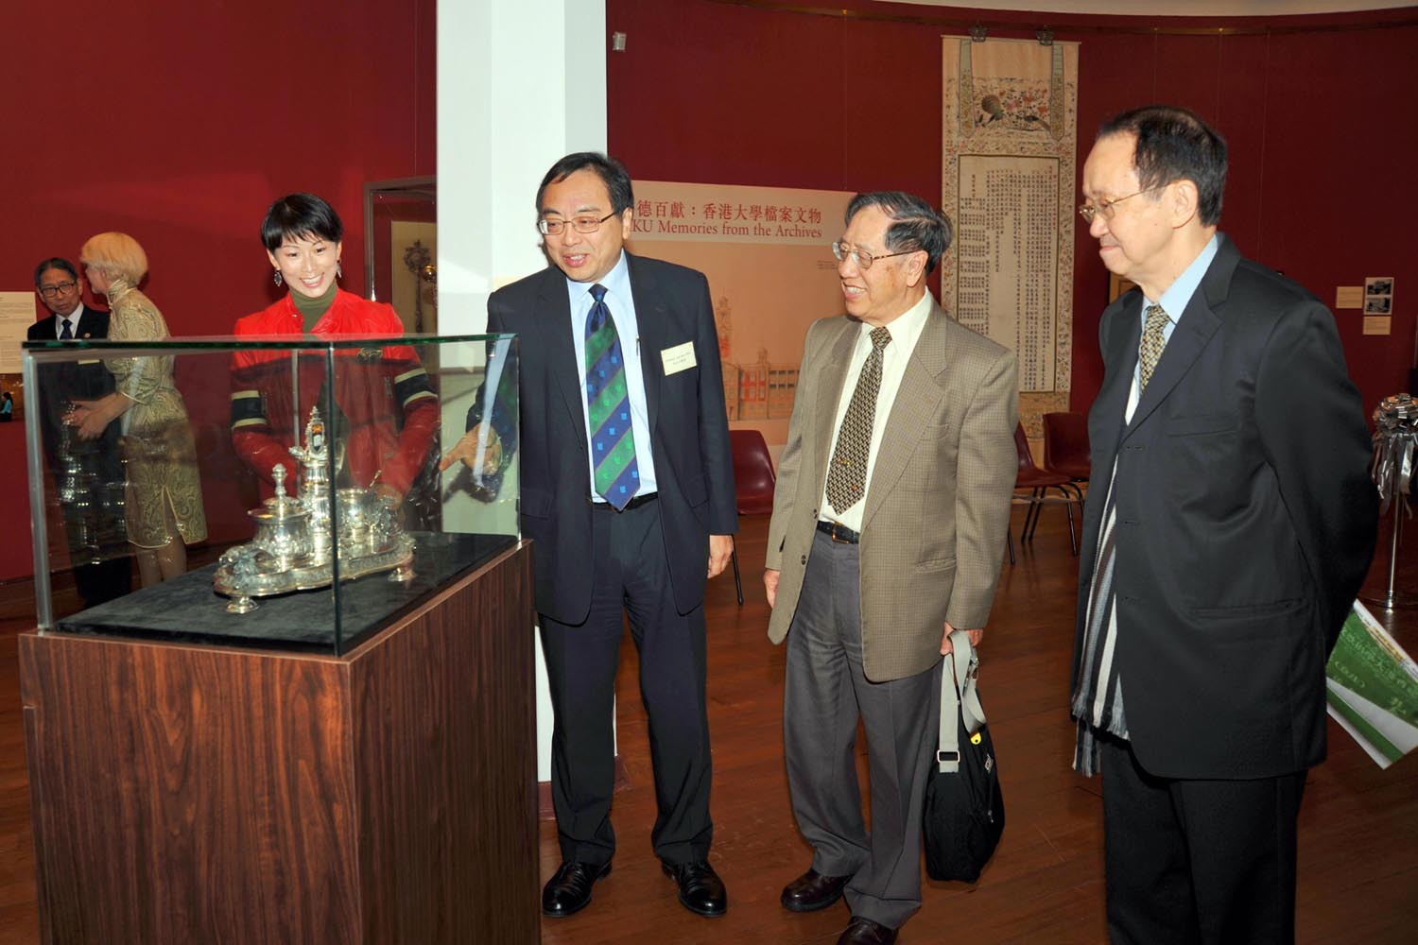
HKU Memories from the Archives (Dec 2011 – Mar 2012)
The University Archives and the University Museum and Art Gallery of The University of Hong Kong jointly organised the exhibition on the history of the University through the collections of the University Archives. The exhibition introduces the development of the University from its founding in 1911 to the present day. Over 100 archival records and artefacts are displayed including some from the Libraries, the Museum, private collections and student groups. Many of them have not been exhibited before.
www.hku.hk/hkumag
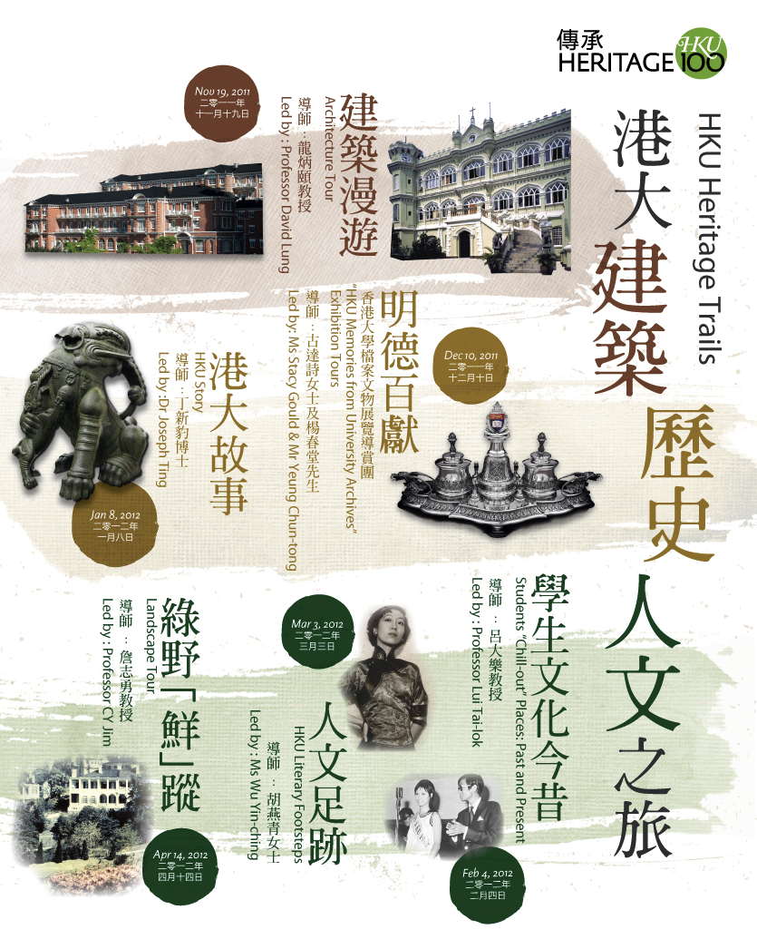
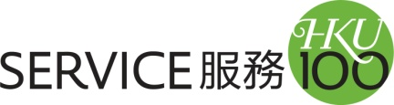
SERVICE 100 reaffirms HKU's commitment to building a better world. Students, staff, alumni and friends will engage in hundreds of community service projects worldwide, mobilising the HKU Family locally as well as across the globe.
http://100.hku.hk/service100

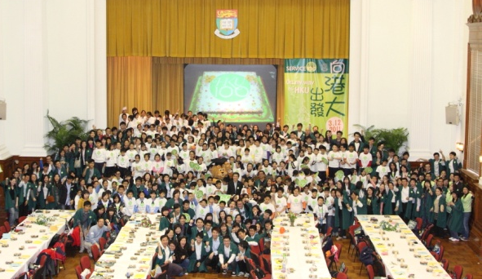
On my way to HKU (Mar 12, 2011)
Over 500 students from Primary Four to Six and various background including grassroots and ethnic minorities, experienced HKU life today and celebrated the University's Centenary with 150 HKU students, staff and alumni at the “On my way to HKU” activity. The event seeks to cultivate in the primary students a positive attitude towards learning and acquiring knowledge, and to aspire them to becoming university students.

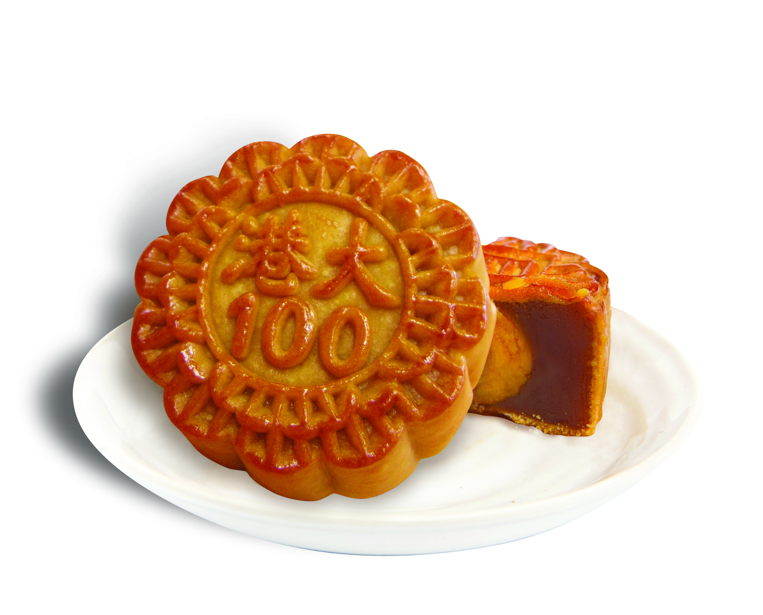
HKU100 Mooncakes
For every box of HKU100 mooncakes which is sold, a senior citizen would receive a gift pack of low-sugar moon cakes and fruits. On the eve of the Moon Festival, 1,000 members from the HKU Volunteer Team visited 2,000 elderly and distributed the gift packs, to share the joy of the Moon Festival with them.

SERVICE100 Fund
To encourage more HKU members to initiate service projects, SERVICE100 Fund has been set up to give financial support to selected service projects. Each service project can apply up to $50,000 to be spend within one calendar year, the amount of support granted is subjected to project merit. Since summer 2011, the Fund has supported more than 20 projects with over HK$300,000 for a variety of community service locally and abroad. Over 480 students are expected to benefit from these projects.
A new round of recipients of SERVICE100 Fund was announced in Nov 2011. 14 new projects, mainly for environmental protection and education service, have been granted a total of more than HK$125,000. Recipients includes student teams that plan to go on volunteer teaching trips to Sichuan and Yunnan, China as well as provide private tutoring to local underprivileged kids. Another funded project plans to create five child-friendly schools with library and teaching facilities in the villages of India.
http://cedars.hku.hk/SERVICE100FUND
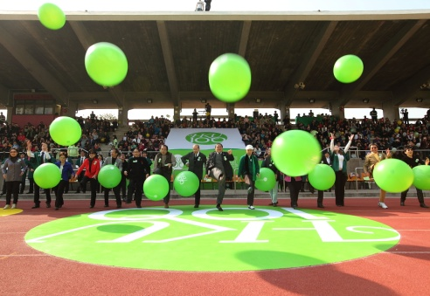
Other highlights:

HKU 100 Kick-off Ceremony (Jan 9, 2011)

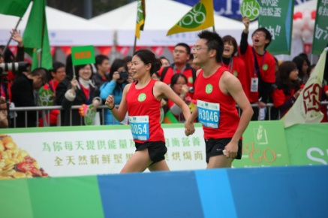

Centenary Marathon Team (Feb 20, 2011)

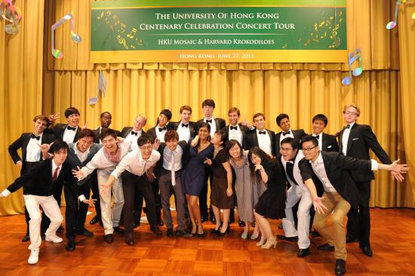

The University of Hong Kong
Centenary Celebration Concert Tour
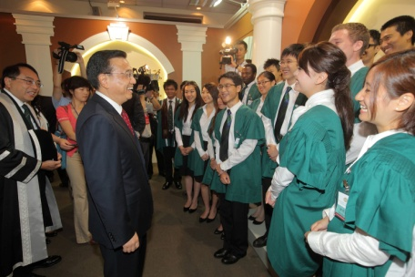
(Jun – Jul, 2011)

The University of Hong Kong
Centenary Ceremony (Aug 18, 2011)
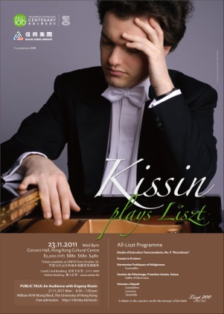

An Audience with Evgeny Kissin and
Kissin plays Liszt (Nov 23, 2011)

The Centenary Gala Dinner (Dec 18, 2011)

Centenary Wine

