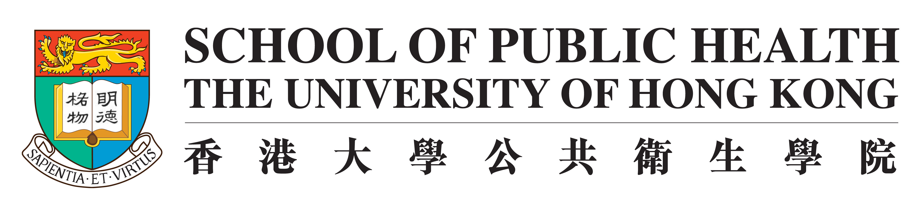
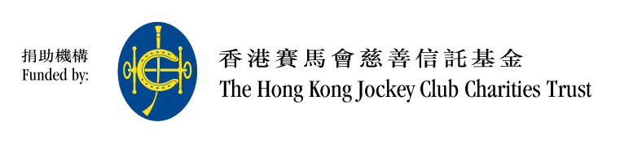

FAMILY: A Jockey Club Initiative for a Harmonious Society

Cohort Study Press Conference

Study on Family Support

An Effective Way to Enhance Family Support – “Happy Family Kitchen Project”

Fact Sheet

Background
The Hong Kong Jockey Club Charities Trust funded HK$250 million and in collaboration with the School of Public Health of The University of Hong Kong, “FAMILY: A Jockey Club Initiative for a Harmonious Society” project (FAMLY project) has completed the first phase of the FAMILY Project cohort study: A population-based household survey from March 2009 to March 2011. The survey covered a variety of topics including family health, happiness and harmony indexes. A second phase household survey began in July 2011, focusing on participants of the baseline household visit.

Objectives
This survey is to investigate the health, happiness and harmony status of Hong Kong “family units”, with each “family unit” represented as a group with a core family and families of its first degree relatives.

Household Survey Period
- Baseline household survey was conducted from March 2009 to March 2011
- Second household survey began in July 2011, and will span a 24-month period

Areas covered
Personal and household information, living habits (including eating habits and physical activities), health status (physical and mental), happiness index, family harmony level, religion, neighborhood relations, work status, use of medical and social resources, etc.

Targets
- Hong Kong residents aged 15 or above who understand Cantonese
- Over 20,000 families were interviewed in the baseline household survey, including 8,481 families (18,906 individuals) randomly selected from the general population (mean age: 46.8; 46.3% male)
- 7,715 families (including 17,082 individuals) with completed data relating to mental health and family satisfaction were included (mean age: 46.4; 46.7% male)
- Second household survey involves all households in the baseline household survey

Methodology
- Sampling was based on a random selection of residential addresses provided by the Hong Kong Census and Statistics Department
- A family was eligible when all members aged 15 years or above, who lived at the same address and could understand Cantonese, agreed to participate
- All eligible members were interviewed by trained interviewers who entered the data into tablet PCs

21 May 2012

FAMILY: A Jockey Club Initiative for a Harmonious Society

Fact Sheet

Background & Objectives
- Family is the base of every society. No harmonious society can be built without loving family relationships. However, traditional family values inevitably start to change when a society becomes more economically, socially and educationally advanced, as is the case in today's Hong Kong, many family discord cases emerge.
- To help build a more harmonious society, The Hong Kong Jockey Club Charities Trust has invited the School of Public Health of The University of Hong Kong to collaboratively launch a project entitled “FAMILY: A Jockey Club Initiative for a Harmonious Society” with a HK$250 million funding.
- The project is based on the premise that traditional Chinese values of cherishing family relationships can still be adapted to modern-day life, and can help promote the 3Hs – Health, Happiness and Harmony – across generations.

The Programme
- The project comprises three components:

- Territory-wide Household Survey

The survey focuses on the family as a unit. It is preventive in nature, rather than trying to rectify family problems. The survey uses a public health approach that brings together various scientific disciplines such as medical, behavioural and social sciences (including psychology and social work), epidemiology, biostatistics, and environmental science. It links social practices, medicine, education, journalism and the media so as to identify the source of domestic problems and derive a preventive response that is complementary, wide-reaching, pervasive, and cost-effective. Government and other related organisations will be able to use the information and evidence to formulate long-term public policies and programmes.
  - Scope and duration:
        - The following data will be collected: personal and family particulars, lifestyles (such as eating and physical activities), physical and psychological health, happiness index, family harmony index, religious beliefs, neighbourhood relationships, work status, and use of medical and social resources, etc.
        - The survey will last for 6 years. The first household visit was conducted from March 2009 to May 2011. A total of 20,963 household (with 47,696 individuals) were successfully enumerated. The second household visit started in July 2011 to re-visit the households, and expects to be completed in April 2013.
  - Sample selection:
        - A total of 20,963 households have been enumerated. In order to reflect the situation in different stages of life span and community development, other than households from the general population, 5 targeted populations will be sampled: 1) newly weds; 2) households with Primary One students living in Sham Shui Po, Kwun Tong Hong Kong East and Hong Kong South; 3) people with recent health shocks; 4) households living in Tung Chung, Tin Shui Wai or Tseung Kwan O; and 5) a random sample of household members.
  - Research methods:
        - During the survey period, fieldworkers will conduct 2 household visits and conduct in-between telephone and web-based follow-ups. Data collected will be treated in strict confidentiality.
  - Every participating household will become members of the “1% Club” and eligible for all privileges, including free health information services; free access to an e-health platform which can generate real-time personalised health assessment based on the personal health data given (e.g. blood pressure index); and receive updates of the survey's progress on a regular basis. Participants can also call the FAMILY healthcare hotline 8100 0974 for medical advice on their personal health.

- Intervention Projects

  - Five pilot intervention projects were developed, in partnership with four non-governmental organizations (NGOs) and the Department of Health to achieve the goal of promoting the 3Hs in the families.
  - The intervention projects were designed in accordance with public health principles to be cost-effective and sustainable. Each intervention was theory-based with clearly defined, measurable and achievable objectives, was short in duration (four to five sessions), and was brief (two to three hours a session). Participants were encouraged to practice key parenting skills at home. In order to enhance the programme’s sustainability and cost effectiveness, the programmes were delivered by experienced community social workers.
  - Pilot studies of the five intervention projects were conducted in 2009 and early 2010, covering 13 districts. The targeted participants included families with pregnant women and children in primary school. Between 100 and 150 families were involved in each project. Changes in participants’ behaviour and attitudes for the study-specific outcomes, as well as the interventions’ effectiveness in enhancing the 3Hs, were evaluated. The intervention projects are namely:
        - Effective Parenting Programme 《愛+人︰「有教．無慮」家庭和諧計劃》in collaboration with Caritas – Hong Kong,
        - Happy Transition to Primary One《愛+人︰「愉快學習上小一」》in collaboration with Hong Kong Sheng Kung Hui Welfare Council,
        - Harmony@Home《愛+人︰「家多．和諧」計劃》in collaboration with Hong Kong Family Welfare Society,
        - H.O.P.E. (Hope Oriented Parents Education for Families in Hong Kong)《愛+人︰「愛家．Teen希望」》in collaboration with Hong Kong Christian Service, and
        - Share the Care, Share the Joy《愛+人︰「共育共樂」》in collaboration with the Maternal and Child Health Centres of the Department of Health.
  - With the positive results of the pilot intervention projects, two larger main studies were started in July 2010, in collaboration with the Hong Kong Caritas and Hong Kong Family Welfare Society. The studies employed improved content, larger sample sizes and more districts.
  - A new intervention project was launched in June 2011 in collaboration with the International Social Service (Hong Kong Branch), namely “Adding More Positive Energy Programme”《「愛+人‧家添正能量」計劃》, to help strengthen resilience in new immigrant families.
  - A school programme was launched in April 2012 in collaboration with the Tung Wah Group of Hospitals, namely “More Appreciation and Less Criticism” 《「多讚少彈康和樂」計劃》. This project aims to increase appreciation and decreasing criticism in 1,000 parents and their school-aged children.
  - The Intervention Team is actively working with different non-governmental agencies (NGOs) or social service agencies to explore the feasibility of launching different interventions programmes to meet the diverse needs of people in the community.

- Public Education – Health Communication

  - The 3Hs messages were disseminated to the general public through various channels to raise their awareness of family values and enhance their communication and participation. Community-wide events were held to promote family 3Hs and provide an opportunity for fostering relationships among family members.
  - Different media tools, such as newspapers, magazines, the Internet, television and advertisements were used to promote positive attitudes towards family 3Hs and enhance the public’s awareness of family values.
  - The School of Public Health of The University of Hong Kong conducts a cross-sectional telephone survey every year to assess changes in behaviour among the general public and the effectiveness of the programmes in promoting family 3Hs. The first and second population-based surveys, entitled “Hong Kong Family and Health Information Trends Survey” (HK - FHInTS), were completed in 2009 and 2010. Results were released in a press conference held on September 26, 2010. The results were widely reported by the mass media and have successfully aroused public’s awareness on the family 3Hs message. The third survey will be conducted in 2012.
  - Training workshops, seminars and symposiums, using appropriate communication strategies, will be organised to share experiences and to develop a critical mass of social and community workers capable of promoting the 3Hs.
  - A public education programme, nine-episode “Love Family” TV series, was produced by the Radio Television Hong Kong (RTHK). The thirty-minute programme was broadcasted on TVB Jade at 8:00 pm Saturdays from January 23 to March 27, 2010. A ceremony was held on 17 January, 2010 at Times Square, Causeway Bay to announce the launch of the series.
  - In collaboration with government department and two NGOs, four community-based participatory projects have been initiated with the aim of promoting family 3Hs through local organisations and agencies:
        - Happy Family Kitchen – Phase I 《「快樂家庭廚房」計劃(第一階段)》in collaboration with The Hong Kong Council of Social Service with the participation of over 19 NGOs, schools, and community groups in Yuen Long;
        - Learning Family《「齊來學‧愛家」計劃》in collaboration with Christian Family Service Centre in Kwun Tong;
        - “Enhancing Family Well-Being Project《「家」「深」幸福計劃》in collaboration with Social Welfare Department – Sham Shui Po District Welfare Office and over 40 NGOs, schools, community groups and government department was launched in Shum Shui Po; and
        - Happy Family Kitchen – Phase II《「快樂家庭廚房」計劃(第二階段)》in collaboration with the Hong Kong Council of Social Service with the participation of over 23 NGOs, schools, and community groups in Tsuen Wan and Kwai Tsing.
Rigorous and longitudinal evaluations were being conducted to assess the effectiveness of these innovative community-based interventions in promoting family 3Hs in the community.
  - In collaboration with the Sha Tin District Council, “Sha Tin Family Fun Fest” was organised in December 2010.
  - In 2010-2011, a project–based programme with the theme of “FAMILY Goes Green” was completed in 85 primary schools from six designated districts. Over 18,000 P.4 to P.6 students and their families actively participated in the educational activities with the aim of obtaining a deeper understanding of family 3Hs.
  - In March 2012, a new drama project involving 100 schools was launched in collaboration with the Boys’ and Girls’ Clubs Association of Hong Kong, namely “3Hs Drama Project” 《「家添戲FUN」計劃》. This project aims to enhance family 3Hs and promote positive communication in senior primary school students and their families through drama performances.

19 May 2012

