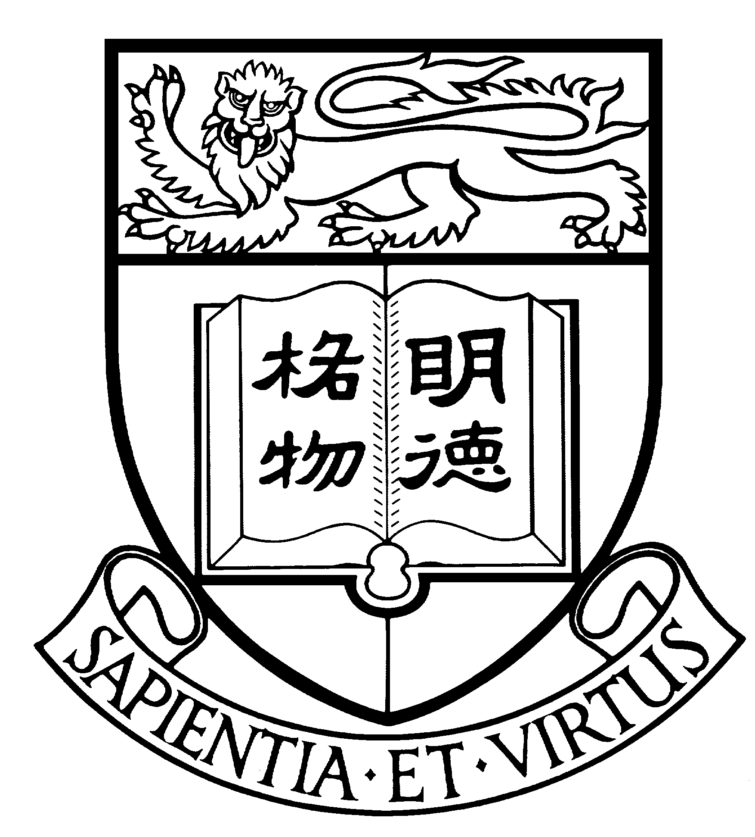

Communications & Public Affairs Office
The University of Hong Kong

Enquiry: 2859 2600
Website: http://www.hku.hk/cpao

Learning experiences of two “First-in-the-Family” students

Two First-in-the-Family (FIFE) Fund recipients Neil Hui and Winky Hon share their learning experiences as below:

- Neil Hui (Faculty of Dentistry, Year 4)
Neil loves music and has learnt violin since he was eight. Due to family constraints, his family could not afford sending him to private lessons and letting him take violin examination. Yet, his passion for violin grew stronger and stronger and he practised hard. As he grew up, he was eager to improve the family financial situation. He worked very hard and was admitted to HKU with excellent HKCEE results (scoring 7As). With the aid of FIFE Fund, he completed the Violin Grade 8 examination when he was at Year 2. He feels that violin helps him relax and handle the pressure from life and school.

- Winky Hon (Faculty of Engineering, Year 3)
Winky used the FIFE Fund to take part in a volunteer programme in Ghana, Africa where she taught local secondary students English and Mathematics. She also had the opportunity to work closely with a group of local university students there and was inspired by their senses of social responsibility. Upon her return to Hong Kong, she decided to actively engage in other volunteer programmes and hope to help promote the sense of social and world citizenship to her fellow schoolmates and in the community.

“First-in-the-Family Education Fund” Scheme
“First-in-the-Family Education Fund” was established in 2008 with the aim of creating equal learning opportunities for students, who are first generation in their families to attend university, to actively take part in experiential learning activities. While the government provides financial assistance to cover tuition and the basic expenses of tertiary education, it is not sufficient to cover the expenses of these learning activities.

This year, the Scheme supported 300 full-time undergraduate students. So far, over 1000 students have benefited from the Scheme over four years. Each student recipient will each have a bursary of $10,000 to take enriched learning activities throughout their university life. These students come from grass-root families with monthly household income less than HK$13,800.

Paying Forward
The Scheme also advocates the act of paying forward amongst student recipients, who are expected to serve the community and create opportunities for others. Upon their graduation, they will further engage in the advancement of our society.

